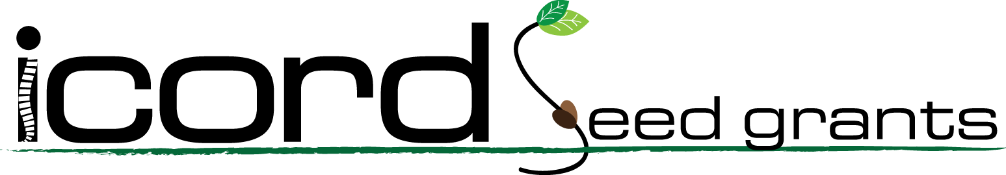
DUE 26 FEB 2026

ICORD Seed Grants are designed to provide seed funding for novel research projects proposed by Principal Investigators and Investigators within ICORD, and enable ICORD faculty members to generate pilot data for future applications for multi-year operating grants (especially Tri-Council) as a result of receiving a Seed Grant. Given the competitiveness of securing funding and the requirement for pilot data in applications, these seed funds intend to foster future funding success for new projects.
Up to 5 projects will be funded (maximum $30K each, plus up to $2K each to support partnership activities). The scope of the projects must be aligned with ICORD's Mission and SCI Research Platform and projects must have a strong likelihood of leading to a new sustainable research program. Proposals may only be submitted by ICORD Principal Investigators or Investigators in good standing.
ICORD members may submit only one application as the primary applicant per round of funding.
Applications will be reviewed by an adjudication committee using a five-point scale (akin to CIHR, with 5 being the best) To maintain a standard of excellence, no applications rated 3.5 or below will be funded. The adjudication committee will include:
- Dr. Nancy Thorogood, ICORD Managing Director
- Three or more of the previous Seed Fund competition awardees.
Application Procedures:
Submit your application files (this form, optional one-page attachment, and CV of any non-ICORD co-applicants) online at https://icord.org/funding-opportunities/seed-grants/
If you do not receive a confirmation message within two hours of submission, please contact admin@icord.org. We anticipate that the competition results will be announced within one month of the deadline.
Eligibility:
- Applicants for ICORD Seed Grants must be ICORD members (Principal Investigator or Investigator level) in good standing. Associate Members, Research Associates, and post-doctoral fellows may apply as co-applicants. Applicants must be pursuing a new area of research that requires seed funding to generate pilot data to apply for a Tri-Council or other operating funding grant applications. Priority will be given to those who will use the data towards attaining their first multi-year Tri-Council grant as a PI, followed by those applying to a different Tri-Council agency (in which they have not held funding as a PI), and then to those applying for renewals or other funding types (e.g., Heart and Stroke Foundation).
- Only one Seed Grant application can be submitted each round by the primary applicant. Collaborative applications are encouraged and there is no limit to the number of applications one can be listed as a co-applicant.

Judging Criteria for the proposals include:
- The appropriateness of the research plan, including its feasibility and the use of the best available methodology;
- The significance/impact of the work proposed and its originality, or novelty of the concepts, ideas or hypotheses being pursued in the application;
- The suitability of the research environment, including the availability of facilities, personnel, and time, required to complete the work proposed;
- The alignment of the proposed research with ICORD's Mission & Research Platform and the likelihood that a successful proposal will lead to a sustainable program.
Conditions of Award:
- Grants must be activated within 6 months of notice of award (including all necessary approvals), if the grant is not activated; the funds may revert to ICORD.
- An interim report is due one year from the award date, and a final report will be due no later than 2 months after the end date. Any unspent funds remaining at that time will be returned to ICORD. A report template will be provided along with the award notifications.
  - Please send your report to Dr. Nancy Thorogood (thorogood@icord.org).
- Award winners may be required to assist in the adjudication of applications in the next cycle.
- Award winners must report annually on submitted grant applications and funding leveraged from Seed Grant-supported pilot data or preliminary work.

Mission & research platform:
ICORD’s mission is to conduct research and training towards the development and translation of more effective strategies promoting the prevention of spinal cord injury, functional recovery, and improved quality of life after SCI. Our vision is broad, and therefore, our strategy is not to focus solely on a narrow definition of ‘cure’ for SCI, but rather, to foster excellence across the entire research continuum that affects the lives of those with SCI. This includes preclinical discovery science, the development of therapies for acute and chronic SCI, and solutions for successful and fulfilled living with SCI.
ICORD’s research activities revolve around these four strategic goals:
1. Prevention of SCI
2. Acceleration of SCI cures/treatments
3. Improving the quality of life for people with SCI
4. Supporting activities of our partners
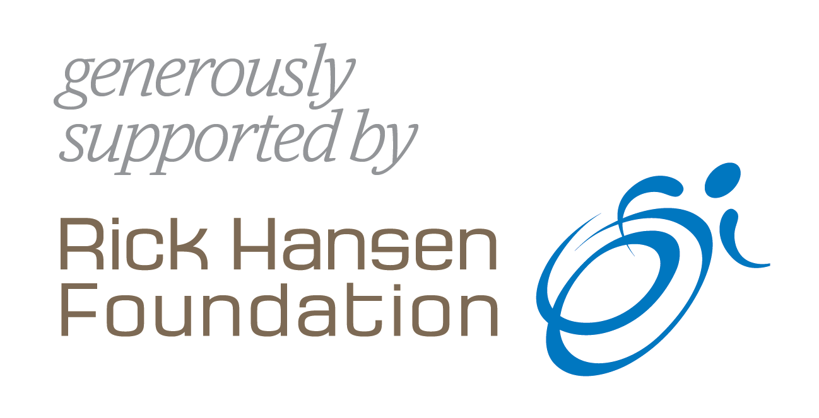

Principal Applicant

Name (Surname, Given Names):
Affiliation:
Department (s) | Institution

Co-Applicant(s):

If PI or Co-Applicants are not ICORD PIs/Investigators, please upload short CV.

Name (Surname, Given Names):
Affiliation (Department / Institution):
Name (Surname, Given Names):
Affiliation (Department / Institution):

Name (Surname, Given Names):
Affiliation (Department / Institution):
_________________________________________________________________________________________________________________________________________________________________________________________________________________________________________________________________________________________________________________________________________________________________________________________________________________________________________________________________________________________________________________________________________________________________________________________________________________________________________________________________________________________________________________________________________________________________________________________________________________________________________________________________________________________________________
_________________________________________________________________________________________________________________________________________________________________________________________________________________________________________________________________________________________________________________________________________________________________________________________________________________________________________________________________________________________________________________________________________________________________________________________________________________________________________________________________________________________________________________________________________________________________________________________________________________________________________________________________________________________________________

Project title:

Amount requested:

Applicant's Signature:

Signature | Date

Research summary (for lay public)
Please provide a summary of the project’s objective(s), potential results and impact for people with SCI. Use plain language appropriate for non-experts. (1500 characters including spaces & punctuation).

Research summary (for peer review committee)
Please provide a summary of the project’s objective(s), hypothesis and research plan. Use language appropriate for a peer review committee. (2000 characters including spaces & punctuation).

Research proposal
Provide a clear, concise description of the research proposal. Maximum of one page (5000 characters including spaces and punctuation). You may upload one additional page of references, figures, tables, charts, or photographs.

Alignment with ICORD's Mission and Research Platform
Provide a concise explanation of how the proposed project aligns with ICORD's Mission and Research Platform as outlined in the Strategic Directions Implementation Plan. (maximum 600 characters)

Plan to Secure Future External Funding
Provide a concise description of how completion of the proposed project will lead to future funding from external granting or other sources. (maximum 600 characters)

Itemized Budget + Justification
Provide estimates for the research project. Each budget item should be supported by a short justification statement and include applicable taxes. Maximum 1 page (5000 characters).

Total Requested: $

Research Partnerships
This section is meant to collect information on research partnerships being performed within the context of the Seed Grant program. Our goal is to prompt everyone to consider whether their project could benefit from a partnership approach, either now or in the future. Completion of this section is required; however, responses are not included in the judging criteria.

Please refer to ICORD’s Research Partnership Information document for more information and support to complete this section.

Are you planning to conduct your study in partnership with research users?
Yes No

If yes, please provide details about:
(maximum 600 characters for each item below)
- who the research partners on the project will be (Note: Partners are not research participants):
- when and how each research partner will be engaged:
- why you are collaborating with these research partners:
- how partners will share in decision making:
- how might ICORD help your research partnership through the grant cycle:

If no, what future resources do you want from ICORD to help support you in considering research partnerships: (maximum 600 characters)

ICORD is dedicated to improving SCI research partnerships and evaluating how approaches to partnership within ICORD evolve. This evaluation, conducted by ICORD PI Dr. Heather Gainforth and her team, will involve looking at ICORD Seed Grant applications. This application will be shared with them.

All evaluation team members have signed a confidentiality agreement. The partnership data from this evaluation may be shared via publications, reports, and presentations to the scientific and broader community. All shared data will be anonymized and lack identifiable information, all experiment and methods information will not be included. If you have any questions about the evaluation, contact Dr. Nancy Thorogood (thorogood@icord.org) or Dr. Heather Gainforth (heather.gainforth@ubc.ca).

TOTAL APPLICATION LENGTH MAY NOT EXCEED NINE PAGES (not including co-applicant CVs, if attaching)

